ART IN THE ATTIC PARTICIPATION PACKAGE

“ART IN THE ATTIC” is the flagship Art Show of the Almonte & Area Artists’ Association (4As). It is held each May, on Mother’s Day weekend at Old Town Hall on Bridge Street in Almonte.

This is information primarily for new participants; the show is set up similar to a classic Art Show which suits the wonderful environment in the Ron Caron Auditorium at the Old Town Hall.

This is a “community show” in every way. It takes our entire membership to assist. We encourage our members who choose not to show their work, to help with the show in some manner. During the show set-up and during the show hours, we count on each other. The show set-up would not be possible without the help from participants, members and friends. Volunteer opportunities are listed on the Invitation to Participate application form.

Promotional assistance is also welcome from members who are not participating in the show. Show participants should assist in at least two of three ways. 1. Beginning in March, assist with social media communications through their community memberships and client network. 2. In April, post printed media in locations close to home and work. 3. Two weeks prior and post-show, put out and retrieve road signs in their local community.

The 4As own and maintain display boards which are stored by the town in the Auditorium. These display boards are 4’ x 8’ two-sided plywood boards painted white which are erected with poles, joined together in rows.

The artwork is hung from chains attached to a custom-made clips supplied by the 4As. Chains and “S” hooks, also supplied by the 4As, attach to the chains and the artwork is hung on these “S” hooks.

(Show photos)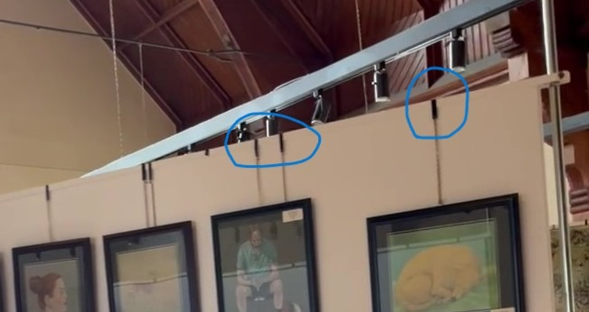
PHOTOGRAPH 1 Circled pieces show the clips that hold the chains
You can also see one of the poles that support the board on the right-hand side of the board in this picture.

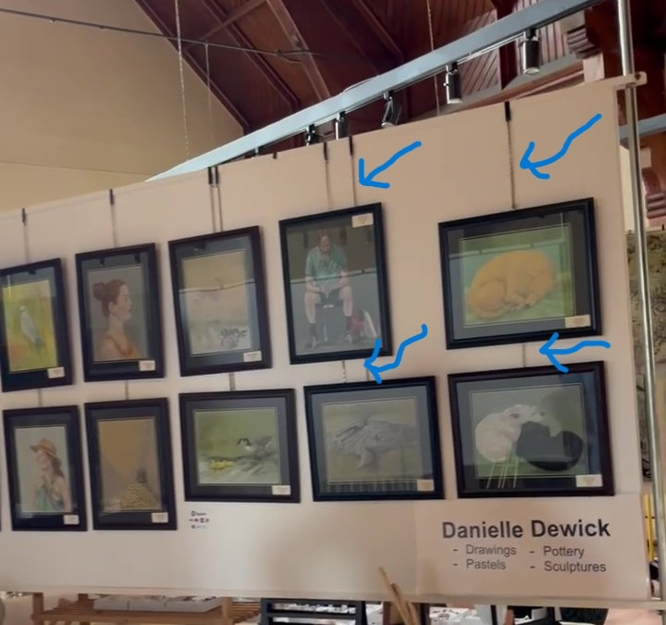
PHOTOGRAPH 2 Circled pieces show the chains

Please put your labels onto the white boards using blue or green painters’ tape, looped on the back of your labels. Regular masking tape and most of the gummy or UHU sticky pads, leaves a residue on the painted boards which prevents paint touch ups from adhering properly. No nails, tacks, or gummy labels are to be attached to the white boards.

Each artist is responsible for their own booth: from the set-up, for each financial transaction, to be in attendance at the entire show, to the take-down of your own work. When you require a short break from your booth, please ask a neighbour to cover you for a few minutes.

A fridge is available in the kitchen area if you wish to store you lunch or drinks. The 4As supply coffee and tea in the little kitchen area. Milk and cream will be in the fridge. We ask that you wash your cups at the end of each day.

More detailed information will as we get closer to the show.

Many thanks.

Art in the Attic Committee

